

Ben-Gurion University of the Negev Faculty of Engineering Science

School of Electrical and Computer Engineering Dept. of Electrical and Computer Engineering

Fourth Year Engineering Project
PDR

Design and Implementation of a Hovering Autonomous Underwater Vehicle (HAUV)

Project Number: p-2026-031
Students (Name and ID) : Guy Hatzir - 207015272
Maayan Sarig - 206511776
Supervisors: Prof. Hugo Guterman
Email for contact: guyhatz@post.bgu.ac.il
sarigma@post.bgu.ac.il
Submitting date: 15/11/2025

Table of Contents
1 Abstract 3
i. English Abstract 3
ii. Hebrew Abstract 3
2 Spec Sheet 3
2.1 Product Proposal 3
2.2 Technology - Methodology 4
2.3 Research and work stages 5
2.4 Potential Applications 5
2.5 System Performance Specifications ………………………………………………………6 2.6 System Schematic ………………………………………………………………………...6
2.7 System Input-Output………………………………………..……….………..……………6
3 Literature Review 6
4 Testing Plan 7
5 Bibliography 8

- Abstract
  - English Abstract
A Remotely Operated Vehicle (ROV) is typically controlled from a manned surface platform via a computer and joystick. The primary challenge is that conventional RF communication does not propagate underwater, necessitating a reliable, two-way communication link to the surface. This project aims to enable the ROV to perform autonomous operations and be operated remotely, without the constant presence of a manned platform.
The project introduces an innovative concept: an Unmanned Surface Vehicle (USV) that serves as a communication relay between the ROV and the remote-control station. This floating unit will communicate with the main vessel via long-range links and transfer predefined missions to the ROV for execution.
The expected outcome is the successful execution of autonomous scanning missions within a predefined area, initiated by commands from the surface vessel, while maintaining stable communication between the ROV and the surface via the USV.
Keywords: ROV, USV, autonomous operation, RF, Remote Control, Underwater.
  - Hebrew Abstract
רכב תת-ימי בלתי מאויש בשליטה מרחוק (ROV) נשלט כיום מפלטפורמה מאוישת על פני המים, באמצעות ממשק הכולל מחשב וג'ויסטיק. האתגר העיקרי טמון בעובדה שתקשורת RF קונבנציונלית אינה עוברת מתחת למים. לכן, נדרשת שמירה על תקשורת דו-כיוונית אמינה מעל פני המים. פרויקט זה שואף לאפשר ל ROV לבצע פעולות באופן אוטונומי ולהיות מופעל מרחוק ללא נוכחות קבועה של מפעיל אנושי.
הפרויקט מציג קונספט חדשני של כלי שיט בלתי מאויש (USV) המשמש כמתווך בין ה ROV לבין תחנת השליטה המרוחקת - הספינה. יחידה צפה זו תתקשר עם הספינה באמצעות קישורי תקשורת ארוכי טווח, ותעביר את המשימה המוגדרת מראש לביצוע על ידי ה ROV.
התוצאה הצפויה תהיה ביצוע מוצלח של משימות סריקה אוטונומיות בתוך אזור מוגדר מראש, אשר יופעלו על ידי פקודות מכלי השיט שעל פני המים, ושמירה על תקשורת יציבה בין ה ROV מתחת למים ל USV מעל פני המים ולספינה המאוישת המרוחקת.
- Spec Sheet
  - Product Proposal
The primary purpose is to decouple the operator from the ROV’s immediate vicinity, breaking the limitation of a direct, physical tether from the main vessel. This new system allows an operator on the mother ship to function as a mission planner rather than just a pilot. The operator will use “QGroundControl” software to send high-level mission directives over long range (WIFI Link) to the USV (Slave). The USV acts as a smart communication relay and local supervisor. It receives the mission and forwards commands to the ROV (Master) via a short fiber optic tether. The ROV, which will be upgraded with its own autonomous navigation system, executes the complex mission independently while the USV autonomously follows it. This architecture is fundamentally:
- Increases operational range beyond the typical ROV tether.
- Enables complex, large-scale autonomous surveys (e.g., scanning a large area) without continuous, fatiguing manual joystick control.
  - Technology - Methodology
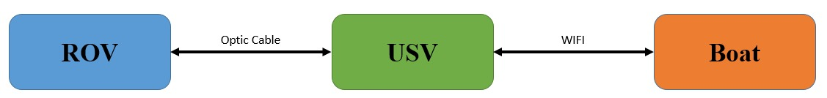
This architecture will be based on three separate, distributed control architectures:
Figure 1
Mother Ship: The control protocol will be “MAVLink”, managed by “QGroundControl” software system on the ship. This protocol will encapsulate TDMA packets for wireless transmission.
USV: A Raspberry Pi 4 (RP4) on the USV will act as a central communication hub and gateway. It will manage the WIFI link to the mother ship and the fiber optic link to the ROV (FXTI). The USV will be equipped with:
- GPS - antenna and receiver for its own location (for station keeping).
- FXTI - A media converter to transfer data from Ethernet to the fiber optic cable and vice versa.
The USV will be controlled by its own thrusters and sensors, managed by a flight controller, for autonomous station keeping. The USV will be based on a catamaran frame equipped with two thrusters. All components will be housed in a waterproof enclosure mounted on the frame. Furthermore, a tension meter and angle sensor will be installed for the fiber optic cable. This data will be used to keep the cable within its defined technical limits and, by doing so, allow the USV to follow the ROV.
ROV: The ROV functions as the primary autonomous agent. It is equipped with its own Raspberry Pi 4 companion computer and a flight controller running ArduSub firmware. Its methodology is to receive the complete mission (as MAVLink commands) from the USV via the fiber optic link. It then executes this mission autonomously, using its six thrusters and a suite of onboard navigation sensors (e.g., IMU, camera, and depth sensor).
  - Research and work stages
- Stage 1: ROV Firmware Upgrade: Integrate the Raspberry Pi 4, Navigator Flight Controller, and essential navigation sensors (IMU, depth, camera). Install and configure ArduSub firmware.
- Stage 2: USV Fabrication: Complete the mechanical and electrical build of the USV, integrating the battery, Raspberry Pi 4, Navigator Flight Controller, FXTI, GPS, two thrusters, and Wi-Fi & GPS antennas. Install the winch, tension meter, and angle sensor.
- Stage 3: Communications Link Development:
Underwater Link (USV-ROV): Integrate and test the fiber optic link (media converters).
Surface Link (Ship-USV): Procure and test long-range Wi-Fi hardware over water.
- Stage 4: Software & Logic Development:
USV Relay Logic: Develop and debug the MAVLink routing/relay script for the USV's R.P.4. USV Autonomy: Configure the USV's flight controller to follow the ROV based on data from the tension meter and angle sensor.
- Stage 5: System Integration & Testing
  - Potential Applications
- Marine Research: Autonomous ecological surveys, seabed mapping, and water quality sampling.
- Industrial Inspection: Automated inspection of subsea infrastructure (e.g., pipelines, cables, bridge pylons, vessel hulls).
- Aquaculture: Automated monitoring and inspection of fish farm nets and mooring systems.
- Search and Recovery (SAR): Deployment from a safe distance to autonomously scan a predefined search grid.
  - System Performance Specifications
Topic | Component | Value
Communication | Air - WIFI | 2.4/5 GHz, 7 KM
Communication | Underwater – Optic Cable | 1310/1550 nm (single mode)
Navigation | GPS | 1.575 GHz
Buttery Life (ROV+USV) | Normal use | 2-3 hours w/18Ah
Buttery Life (ROV+USV) | Light use | 4-6 hours w/18Ah
Depth | ROV | 100 meters
Table 1
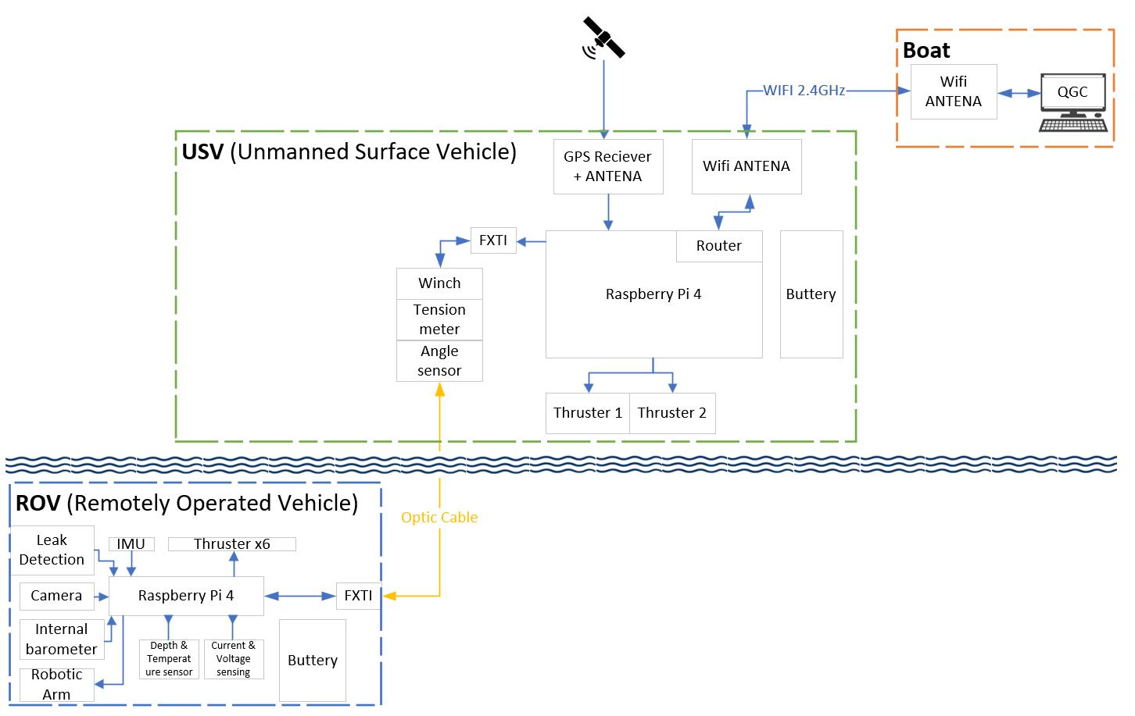
  - System Schematic
Figure 2
  - System Input-Output
Input: The system receives a mission command from the operator, which defines a polygonal search area and specific waypoints.
Output: The ROV returns real-time seafloor video to the operator on the mother ship.
- Literature Review
The proposed system's core is the Unmanned Surface Vessel (USV), which functions as an autonomous, mobile communication relay. The literature identifies this as a key solution to major challenges in maritime operations [4]. A primary challenge is the communication link to the remote operator ("mother ship"). Traditional maritime communication is limited to low-bandwidth VHF or high-latency satellite links [4]. The "USV-Assisted Relaying" concept directly addresses this by using the USV to establish a high-bandwidth, line-of-sight (LoS) wireless link [4]. The FLEXUS USV [3] serves as a key hardware precedent, which proved that a small, lightweight (15kg) catamaran can be a stable platform for long-range, multi-band (2.4/5GHz) Wi-Fi, achieving multi-kilometer data links [3]. The RoboVaaS project [1] further validates this, listing "a dedicated Wi-Fi or WiMAX deployment" as the primary link between its Autonomous Surface Vehicle (ASV) and the shore station [1].
The second critical link is between the USV and the ROV. A small, agile USV [3] cannot support the heavy, large-diameter tethers of traditional ROVs. The "Fiber Optic Reel System" (FOReelS) [2] provides a direct solution, using an "extremely small diameter (750 µm)" reusable, load-bearing fiber optic cable. This system is compact enough to be deployed from a small USV while still providing the "live high-bandwidth data transmission" essential for ROV video and control [2]. This architecture creates a dual-autonomy challenge. First, the ROV must autonomously execute high-level missions, which are relayed from the operator via long-range Wi-Fi [1, 3] to the USV, and then down the fiber optic tether [2] to the ROV. Second, and more complex, is the control of the USV itself. The literature identifies the USV's autonomous navigation as "still an open issue" [4]. The USV must autonomously follow the ROV, manage the tether tension [2], and simultaneously maneuver to maintain the long-range wireless link with the operator [4], a complex integration validated as a concept by the RoboVaaS architecture [1].
- Testing Plan
  - Dry Lab Test: Integrate all components on a bench to test data flow. Success: A command from QGroundControl (QGC) successfully activates the ROV camera, and the resulting data stream flows back to QGC in real time.
  - Pool Test: Conduct a controlled wet test to validate waterproofing, ROV autonomy, and USV station keeping. Success: The USV successfully moves and tracks the ROV, and the ROV successfully executes a search mission from a remotely issued command.
  - Sea Trials: Conduct full-system, open-water trials to test all components under realistic operational conditions. Success: The system is fully functional. In response to remote commands, the ROV executes the mission and transmits real-time data back to the operator via the USV under sea conditions.
- Bibliography
[1] Coccolo, E., Delea, C., Steinmetz, F., Francescon, R., Signori, A., Au, C. N., ... & Zorzi, M. (2023). System Architecture and Communication Infrastructure for the RoboVaaS Project. IEEE Journal of Oceanic Engineering, 48(3), 716-739.
[2] Phillips, B. T., Chaloux, N., Shomberg, R., Muñoz-Soto, A., & Owens, J. (2021). The Fiber Optic Reel System: A Compact Deployment Solution for Tethered Live-Telemetry Deep-Sea Robots and Sensors. Sensors, 21(7), 2526.
[3] B. Ferreira, A. Coelho, M. Lopes, A. Matos, C. Gonçalves, S. Kandasamy, R. Campos, and J. Barbosa, “Flexible Unmanned Surface Vehicles enabling Future Internet Experimentally-driven Research,” in Proc. IEEE Int. Conf. on Communications (ICC), Paris, France, June 2017, pp. 1–6
[4] J.-B. Wang, C. Zeng, C. Ding, H. Zhang, M. Lin, and J. Wang, “Unmanned surface vessel assisted maritime wireless communication toward 6G: Opportunities and challenges,” IEEE Wireless Communications, vol. 29, no. 6, pp. 72–79, Dec. 2022

הערכה לשיחת סקר תכנון ראשוני (PDR)
אם יש צורך, לכל סטודנט/ית בנפרד
מספר הפרויקט: - P-20 שם הפרויקט:
שם המנחה החיצוני:
שם המנחה מבית הספר:
שם הסטודנט/ית: ת.ז:.

3-מצוין | 2-בינוני | 1-חלש | קריטריון | %
 |  |  | הגדרת המטרה - האם מטרת הפרויקט ברורה? האם הוגדרו קריטריונים ברורים ומדידים כמותית לבחינת הצלחת הפרויקט | 20
 |  |  | הבנת הבעיה - האם ניכר שהסטודנטים מבינים את הבעיה ואת הפתרונות הקיימים? האם נערך סקר ספרות רלוונטי? | 20
 |  |  | הצעת הפתרון - האם הגישה הכללית ורכיבי הפתרון הוצגו והוסברו בצורה ברורה? האם הובנו מהות העשייה, הצורך וסביבת היישום? | 20
 |  |  | בדיקת היתכנות - האם הסטודנטים ביצעו מחקר בסיסי לבדיקת היתכנות פתרון לבעיה? כמו כתיבת קוד, ניתוח מעגל, ניתוח מודל מתמטי.. | 20
 |  |  | איכות כתיבת ה PDR - תחביר, הגדרת המטרה, סקר ספרות, תקצירים, מפרט טכני )או הצעת מחקר( והצעת תכנון מפורטים. | 20
הערות:

